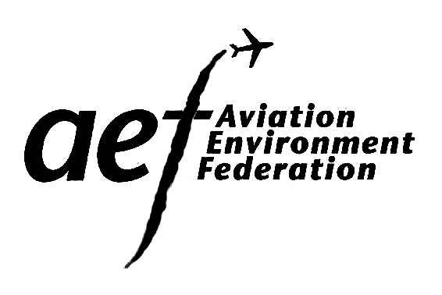
AEF Membership Form
2016

Please complete this form if you would like to join Aviation Environment Federation and would prefer to pay by cheque. There is a secure form available on our website for joining online.

Membership type Fee
Please select

 | Personal (for individuals) | £20
 | Association: under 5000 members | £30
 | Association: over 5000 members | £36
 | Parish Council: under 5000 members | £36
 | Parish Council: over 5000 members | £50
 | Corporate | £175

Your contact details

Organisation ________________________________________________

Title ________________________________________________

First Name(s) ________________________________________________

Last Name ________________________________________________

Phone ________________________________________________

Mobile ________________________________________________

E-mail ________________________________________________

Address ________________________________________________

________________________________________________

Town ________________________________________________

County ________________________________________________

Post Code ________________________________________________

Please identify any airports/ airfields/ issues in which you have a particular interest.
This will enable us to contact you with relevant information

Keeping you up to date

We would like to send you updates about our work and details of events by email and to send you our annual report, AEF’s members-only publication, ‘Flying Green’, and occasional other material, by post.

I would like to receive my communications…
Please select from below

By post and email

By post only

By email only

Agreeing to our terms and conditions

To become an AEF member, you have to agree to our terms and conditions, as outlined on the following page.
Please tick the box below to indicate this is the case

I agree to the terms and conditions of AEF membership including to support the organisation’s aims and objectives.

Payment

Membership fee £

Donation £

Total £

Please make cheques payable to the Aviation Environment Federation, and send to:

The Membership Secretary
Aviation Environment Federation
40 Bermondsey Street
London
SE1 3UD

Please make sure you also return a copy of this form to the address above or by email to info@aef.org.uk.

Thank you for your support!

Signed _______________________________

Date _______________________________
Aviation Environment Federation membership terms and conditions

Benefits

All AEF members are entitled to the following:

- Access to our comprehensive information and advice service. Our dedicated casework officers will deal with your enquiries on all kinds of issues related to aviation policy including, for example:
  - technical data on noise, air pollution and greenhouse gas emissions and on the operation of aircraft and airports (internationally and in the UK);
  - the regulatory framework for aviation: air, environmental, and planning law (including how the planning system works, opportunities to comment, Public Inquiries, and case precedents);
  - who’s who in aviation, Government, the European Parliament, and international bodies, as well as in the legal, acoustic and environmental consultancy fields, and
  - how to deal effectively with aerodrome consultative committees
- AEF’s members-only newsletter Flying Green, covering the latest policy developments and sharing our members’ experiences
- Email alerts of important policy updates or the publication of relevant consultations
- Attendance at our Annual General Meeting (usually featuring a guest presentation)
- The opportunity to stand for election to our Executive Council
- Occasional use of the AEF office facilities in central London, for example as a meeting venue

Aviation Environment Federation aims and objectives

In order to join AEF, you must agree to support our aims and objectives which are set out below:

- to foster a climate of opinion which takes full account of the environmental issues arising from aircraft and aerodrome use;
- to promote a relationship between the environment and aviation in which the detrimental effects of aviation on quality of life and on the natural and man-made environment are kept to a minimum;
- to encourage wide discussion of the problems involved and to seek practical solutions;
- to consult and co-operate with local, national and international governments, the aviation industry, regulatory authorities, universities, professional institutions, research bodies, and any others for the purpose of reducing noise, disturbance and all forms of pollution by technical and operational means;
- to pursue these objectives with policy-making and legislative bodies - local, national and international - so that laws and policies include measures for effective environmental protection;
- to provide relevant advice and information to assist its members;
- to publicise and promote the viewpoint of the Federation through the media and through representation among bodies responsible for aviation matters as appropriate.

Data protection

As a member, your contact details are held on our system to allow us to send you updates about our work and details of events, by email, and to send you occasional material by post. The list is used for this purpose only and is not available to any third parties.

Under the Data Protection Act 1984, we are required to obtain permission for your contact details to be held for this purpose. If you do not wish your details to be kept in this manner, please advise the AEF office in writing.

Please keep hold of this page for your records.

